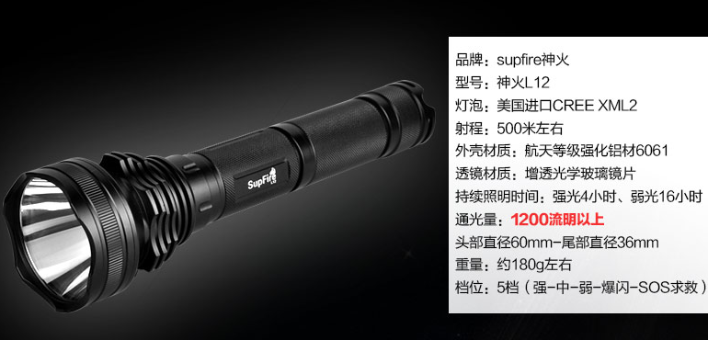

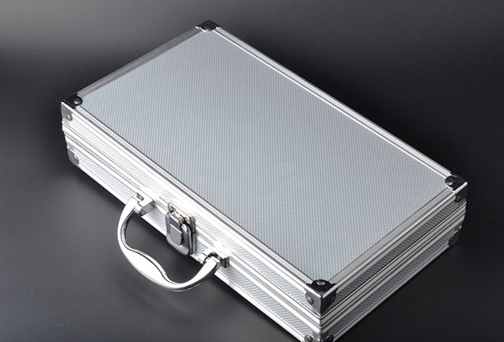

|  |  |  |  |  |
| --- | --- | --- | --- | --- |
| HS Code | Product Name | Price($) | Quantity | Total Price($) |
| [**76129090.00**](http://www.i5a6.com/hscode/detail/7612909000) | 铝盒 / Aluminum Case | 3 | 14 | 42 |

**Product List:**

14 x Aluminum Case with led flashlight accessories.

**From:**

General Manager: Vincent Chen

Company Name: HangZhou NaKu Technology Co., Ltd

Company Address: Binjiang District PuYan Xipu Road 1503# Binke Building,Hangzhou,Zhejiang,China

Post code: 310053

Mobile: 0086-15967129903

**To:**

Moklis Ali,333 ,Buntingford, Hertfordshire,United Kingdom   
Post code:SG99EA

Tel: +44 17632713